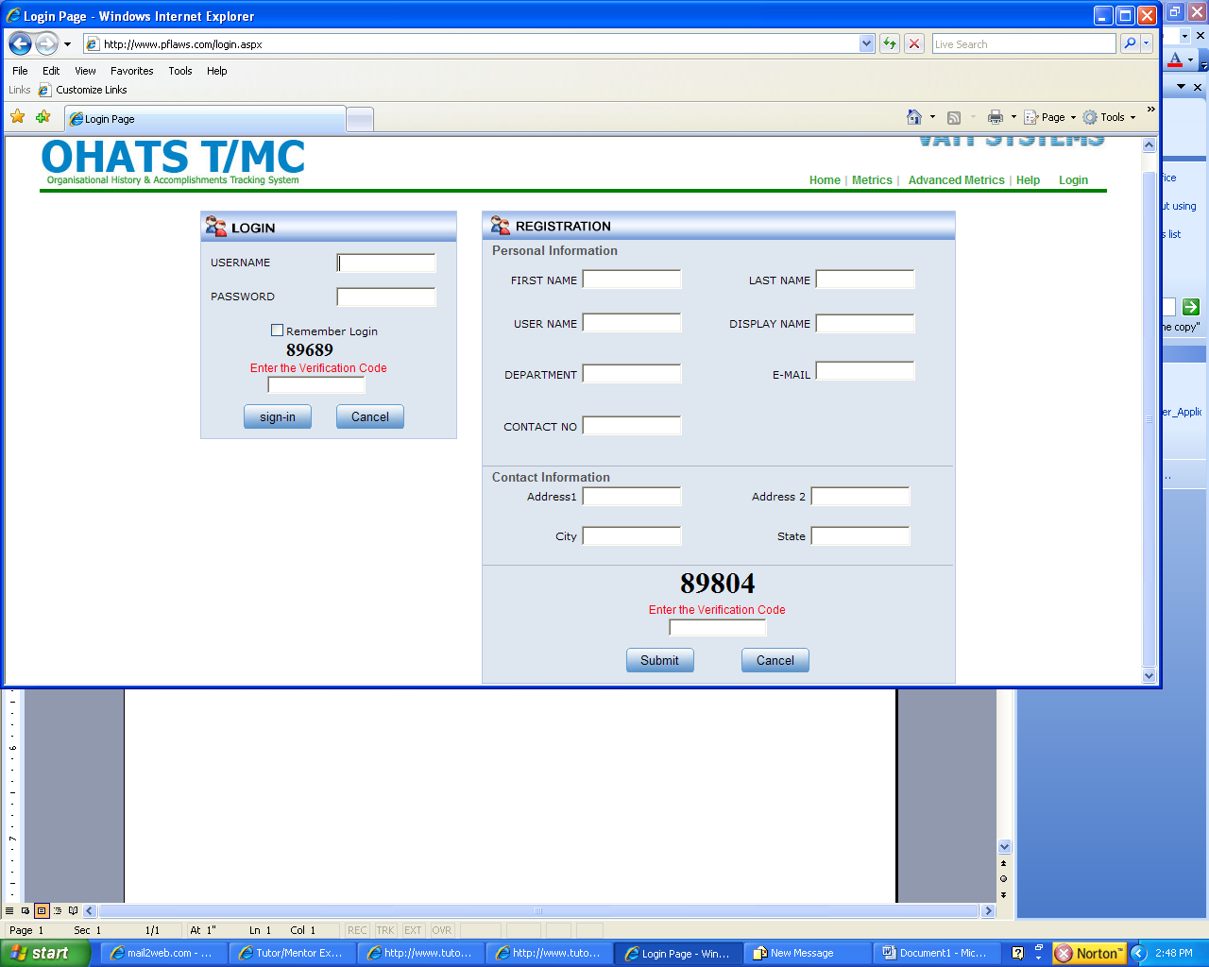

Is this registration intended for new recorders? Or for anyone to view the information on the site? Or both

Does this go to me to approve or not approve?

Is there an admin feature that I can assign usernames and passwords to people already listed as previous recorders?

Issues:

Goals information still needs to be updated from original database to this database. Info did not transfer from first version passed from Steve Roussos to Ganesh.

Names on database = need to remove TMC after each name
Names on database – last name, first name, so we can do alpha sort

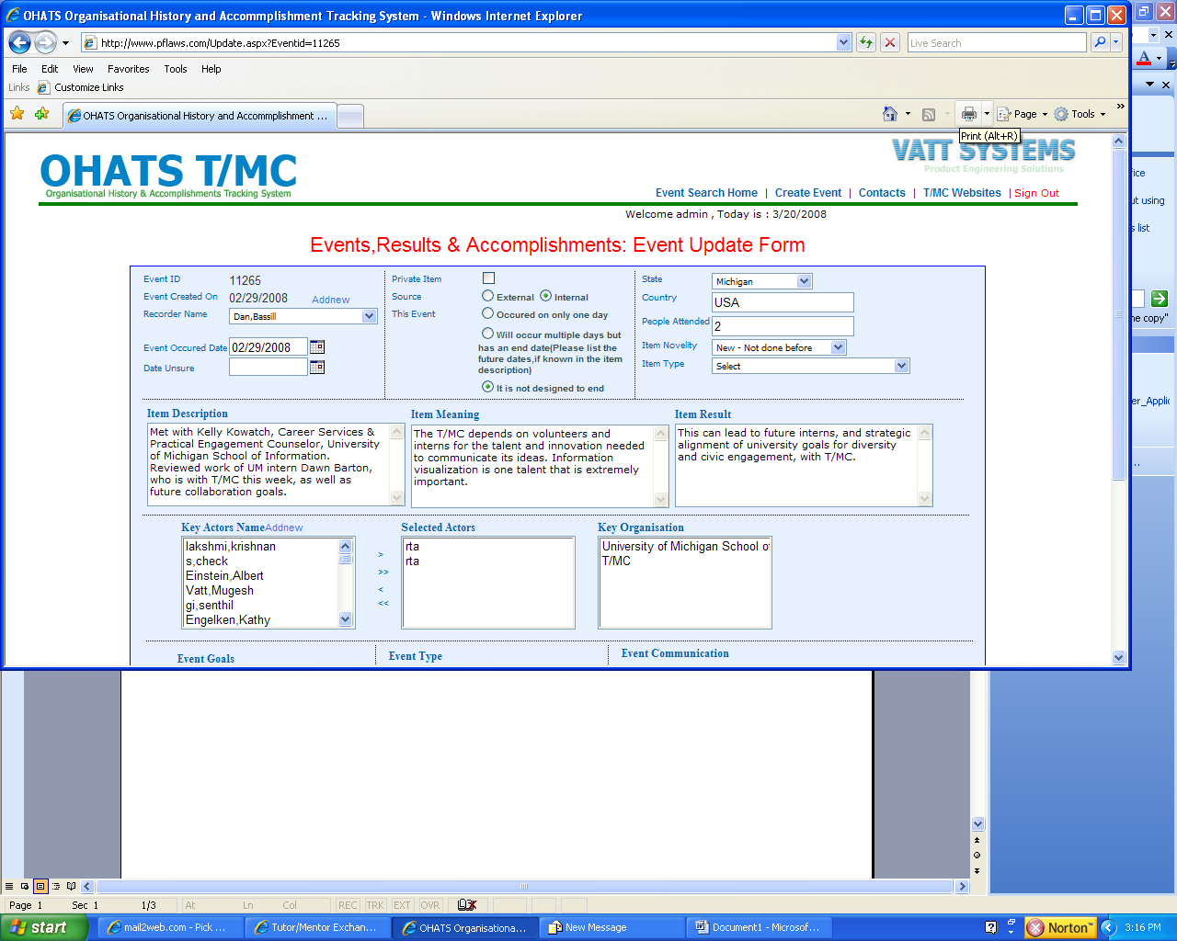

In search, the names of the people don’t match up with the names in the action. The name of the person in the Selected Actors should be Kelly Kowatch, not rta.

When I back space, I don’t get back to the search field, but to the home page, which causes me to re-do the search.

Key Actors list not the same here as it was in the previous version. This list is shorter. TMC before names is not needed.

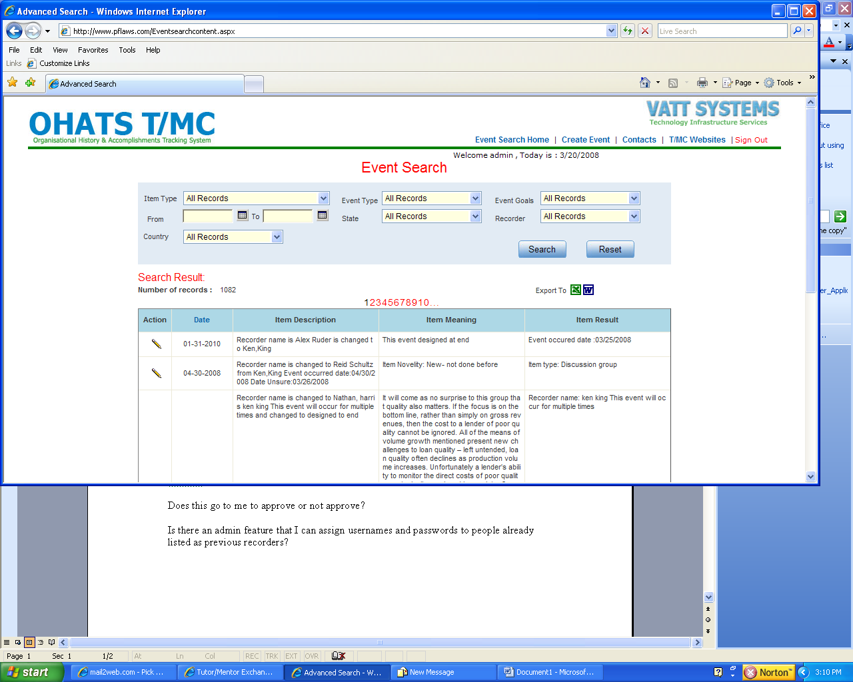

Once we have logged in, we need to still see “metrics”.

What happened to the “archive” page?
My last request was that when people first log in the data they see is the “archived” page data, which can not be edited.

To create event, or edit data, you need to be a recorder, or administrator. The way this is now, anyone can change the data.

